SIMATS ENGINEERING
ASSESSMENT TOOL 3

COURSE NAME: CSA16 COURSE CODE: Data Warehousing and Data MiningQ1
K-Means vs Hierarchical Clustering:
K-Means is faster and more scalable for large datasets because it directly assigns data points to a predefined number of clusters. Hierarchical clustering builds a hierarchy of clusters and is more computationally expensive, making it less suitable for very large datasets. For this small customer dataset, both methods produce similar 2-cluster results, so either can be used; however, K-Means is preferable when scalability and speed are important.
Method | Performance | Scalability
K-Means | Fast | High
Hierarchical | Slower | Lower
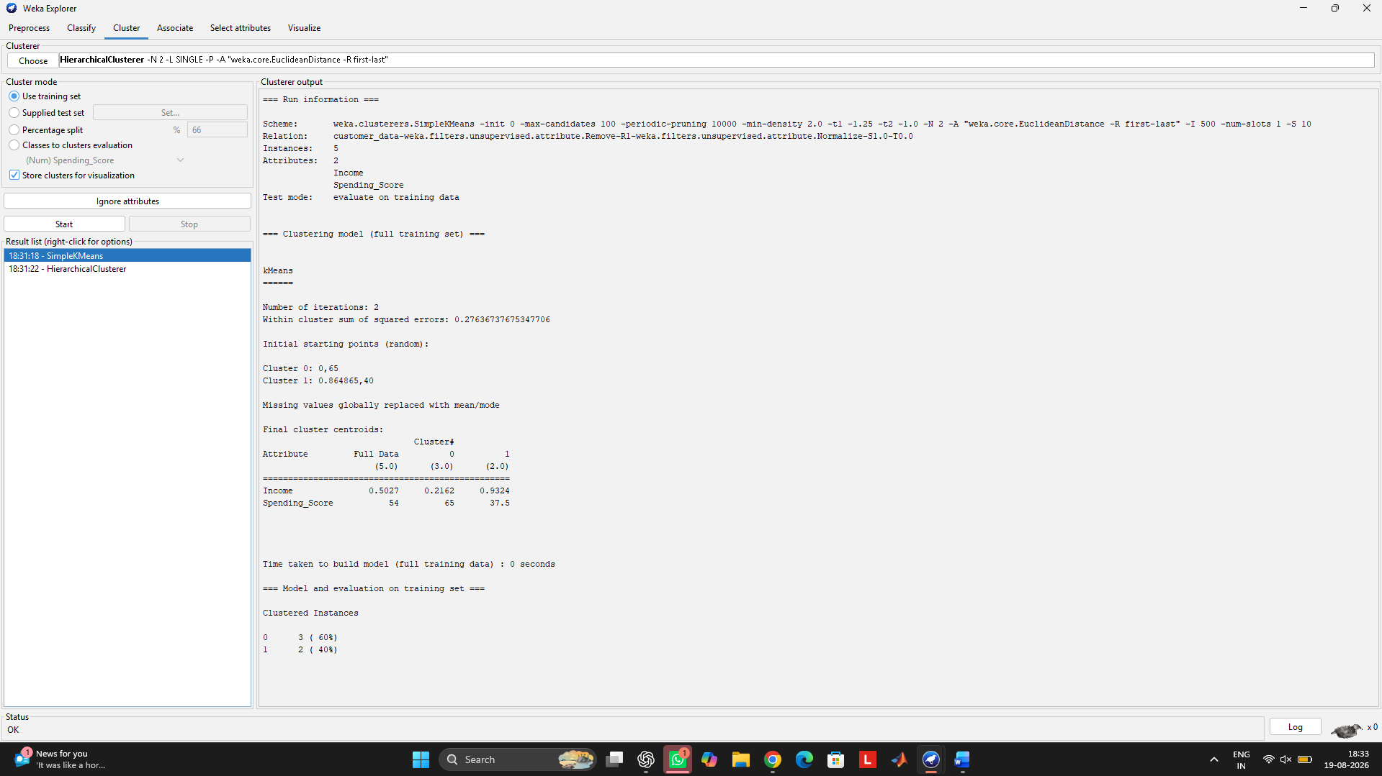
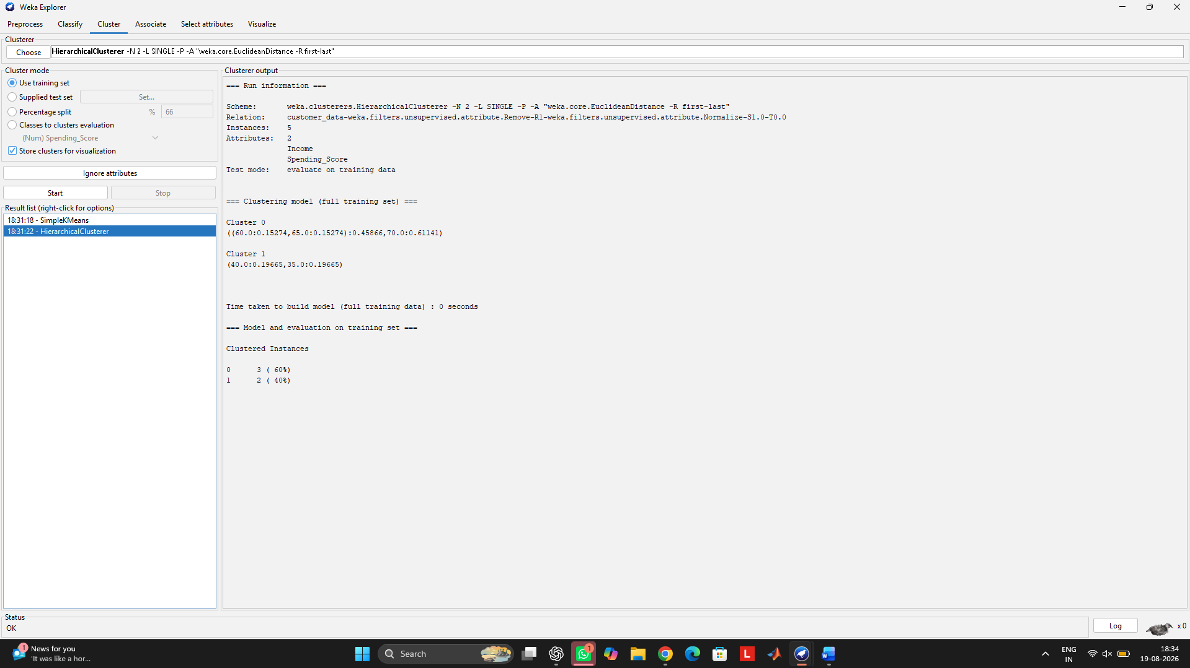

Q2
K-Means vs EM:
K-Means assigns each document to one cluster based on distance, so it works best when clusters are clearly separated. EM (Expectation-Maximization) models the probability distribution of each cluster and can assign probabilities to documents, making it more suitable when clusters overlap. For this document dataset, both methods identify two groups, but EM is preferable for overlapping document clusters because it provides probabilistic membership.
Method | Cluster handling
K-Means | Hard assignment; each document belongs to one cluster
EM | Probabilistic assignment; better for overlapping clusters
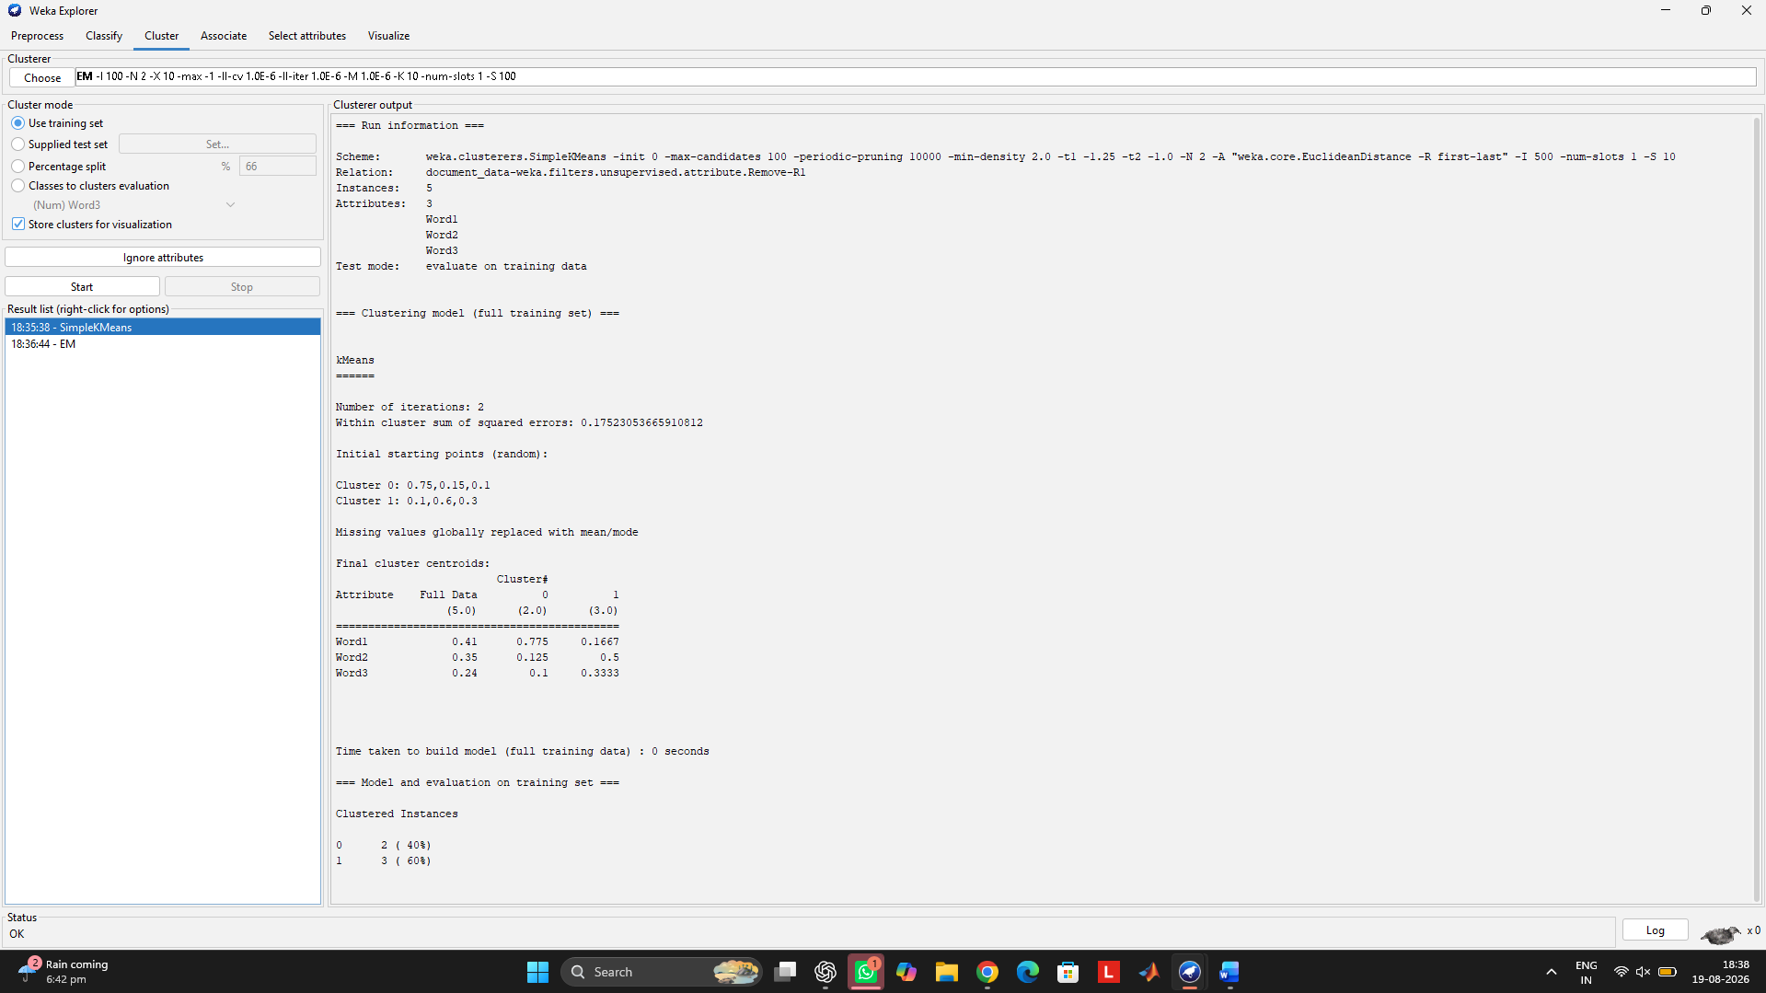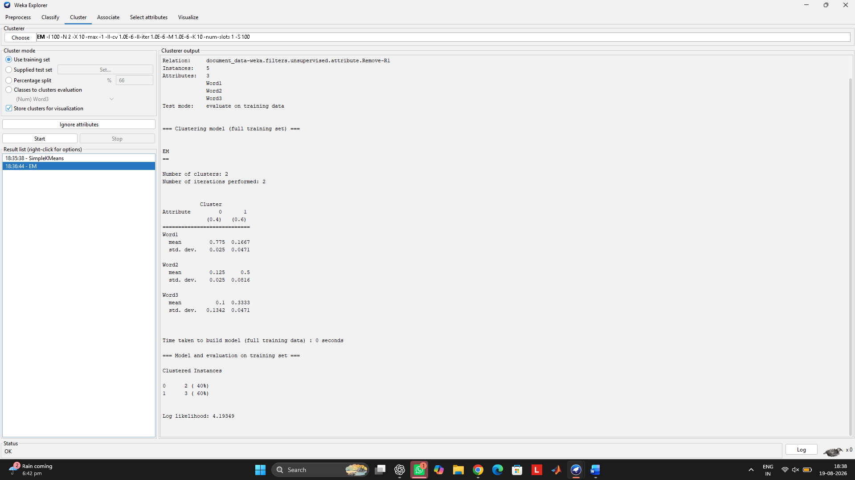

Q3
Euclidean distance measures straight-line distance between geographic points, while Manhattan distance measures the sum of absolute differences in latitude and longitude. Euclidean is generally suitable for geographic proximity, whereas Manhattan can be useful for grid-like movement. In this dataset, both metrics produced the same 2-cluster size distribution (3 points and 2 points), showing that the clustering is relatively stable for these points.
Metric | Result
Euclidean | 2 clusters → 3 + 2 points
Manhattan | 2 clusters → 3 + 2 points
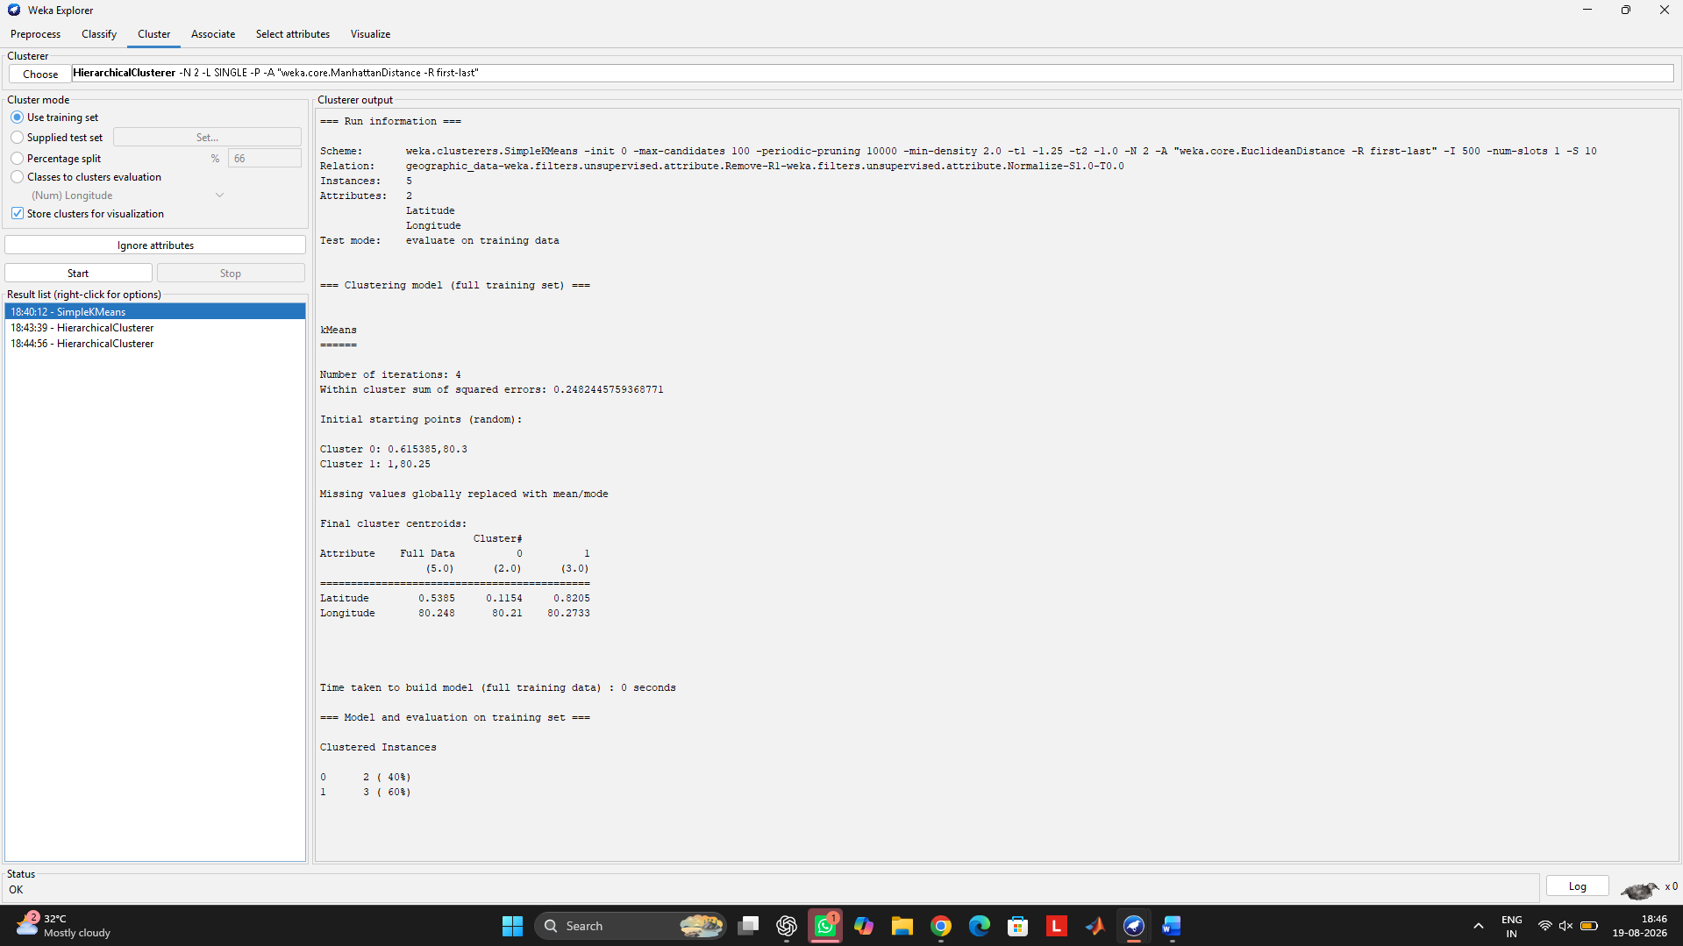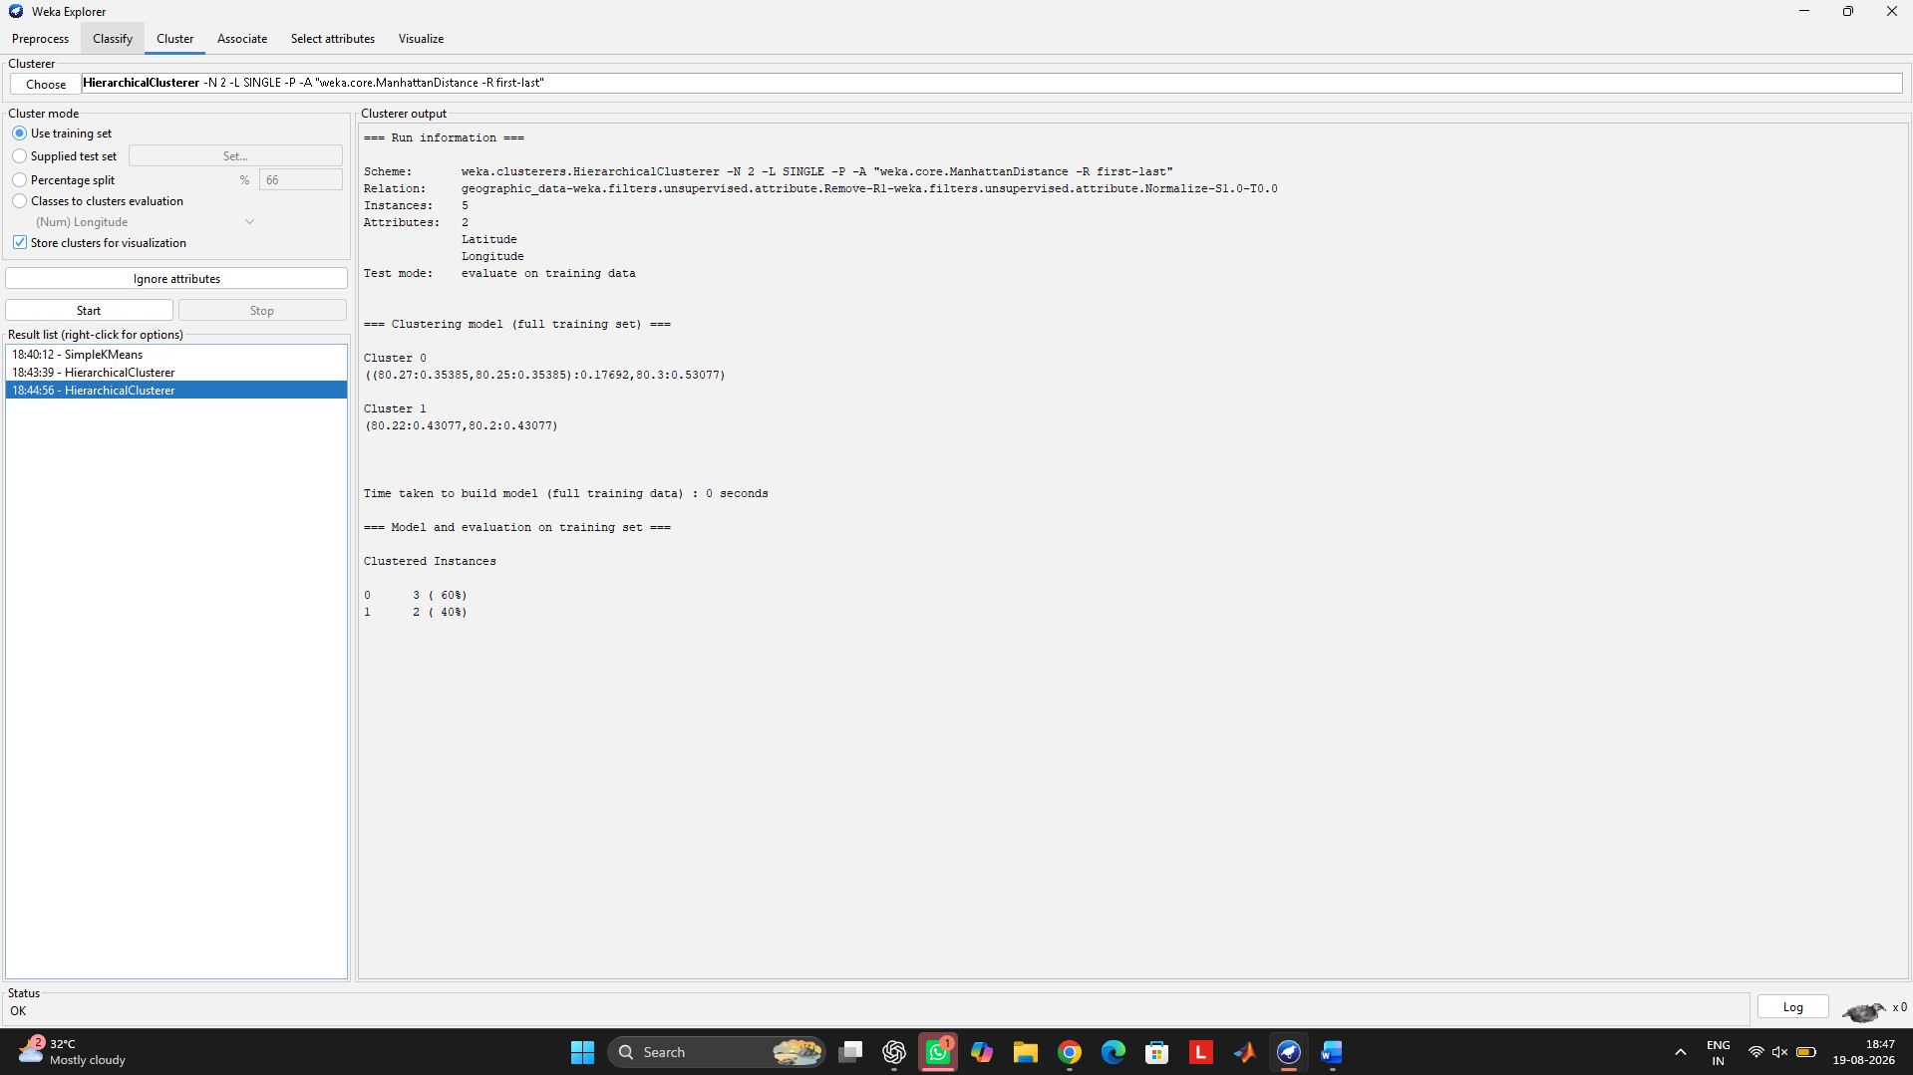

Q4
Agglomerative clustering starts with each product as an individual cluster and progressively merges similar products, while divisive clustering starts with all products in one cluster and recursively splits them. For this small retail dataset, both approaches can identify high-sales/high-frequency products such as P1 and P3 separately from lower-sales products. Agglomerative clustering is more suitable here because the dataset is small and its hierarchical structure is easy to interpret; divisive clustering can be useful when the main groups need to be identified through repeated splitting.
Approach | Process | Suitability
Agglomerative | Bottom-up merging | Suitable for this small dataset
Divisive | Top-down splitting | Suitable when major groups are split recursively
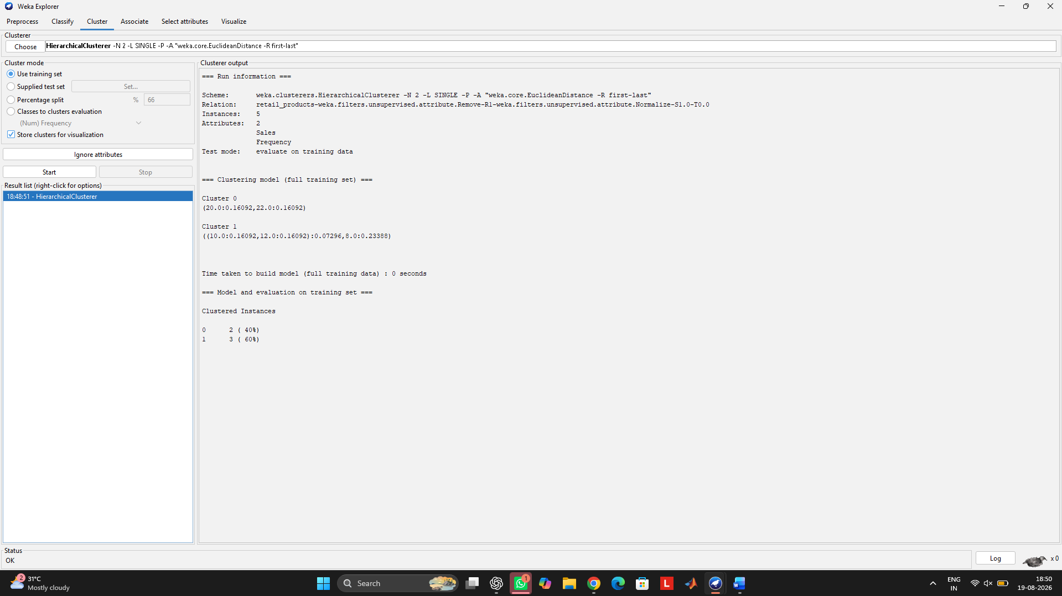

Q5
Centroid-based clustering, such as K-Means, groups data around cluster centroids and works well for compact numeric groups. Density-based clustering, such as MakeDensityBasedClusterer, models the probability distribution/density of the data and can provide more flexible cluster membership. For mixed data containing numeric attributes (Price, Rating) and a categorical attribute (Category), density-based methods can be useful, but appropriate handling of categorical data is required. In this dataset, both methods produced 2 clusters with a 2/3 split, showing similar grouping.
Method | WEKA result | Main advantage
K-Means | 2 clusters: 2 + 3 | Simple and fast for numeric data
MakeDensityBasedClusterer | 2 clusters: 2 + 3 | Uses probability/density information

